C:\Users\atkalcevic\Desktop\socrates_logo.jpg

**School libraries as learning centres**

**Making a difference – sharing best practice**

**Welcome to**



XV. gymnasium, Zagreb, Croatia! 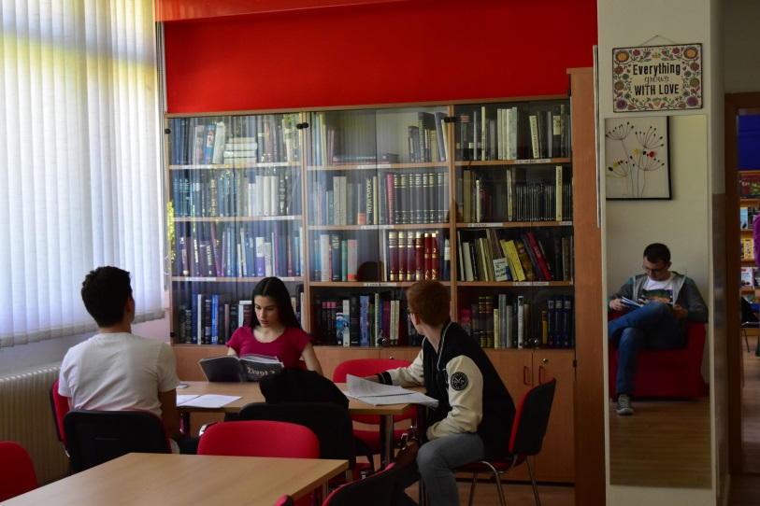 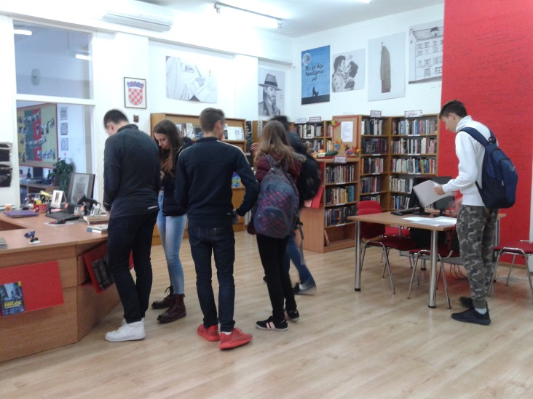 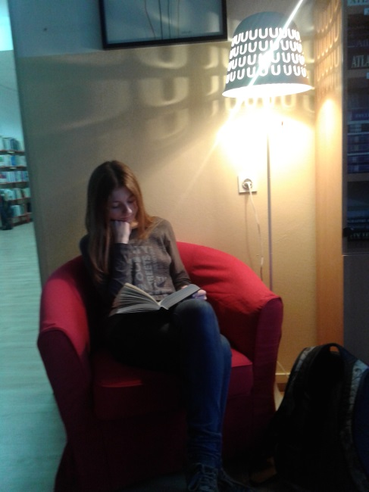 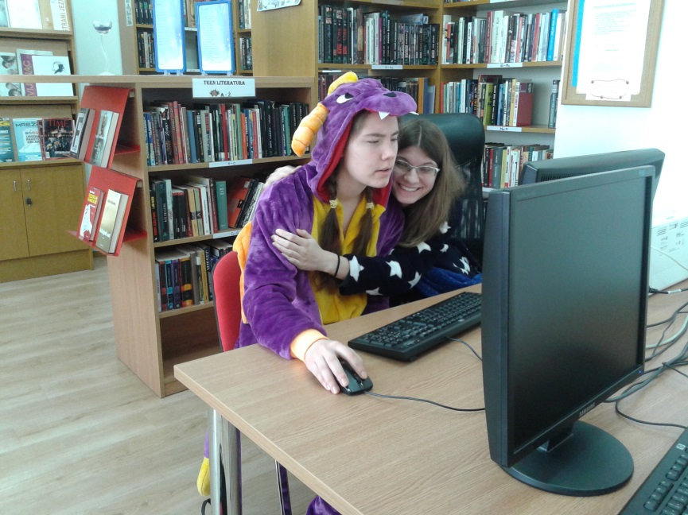

*October, 2017.*